GenAI Activity Pack

GenAI Workshop
NIBM x BOI

Activity Code – 01 | Personalize AI Chat Experience

Tool 1 – ChatGPT (https://chatgpt.com/)
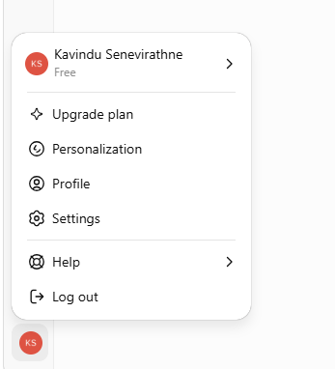

- Go to Settings
- Personalization
- Add Configurations

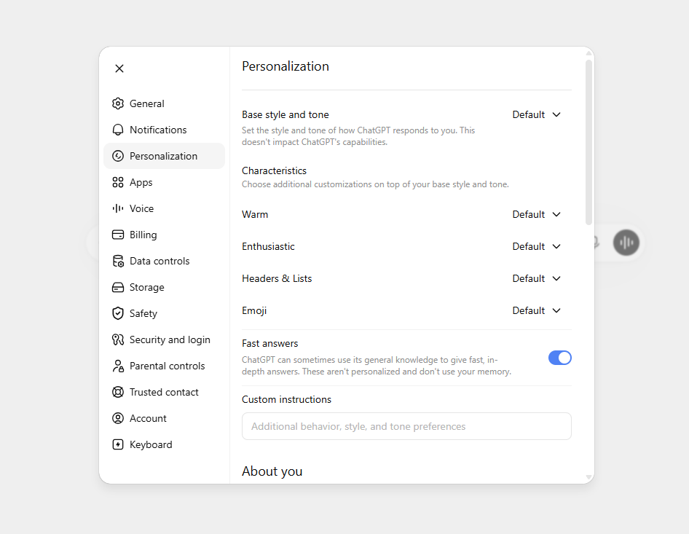
Resources - genai-workshop/Activity-01.md at main · kayifs/genai-workshop
Activity Code – 02 | Personalize AI Chat Experience

Tool 2 – Gemini (https://gemini.google.com/)
- Go to Settings
- Import Memory to Gemini
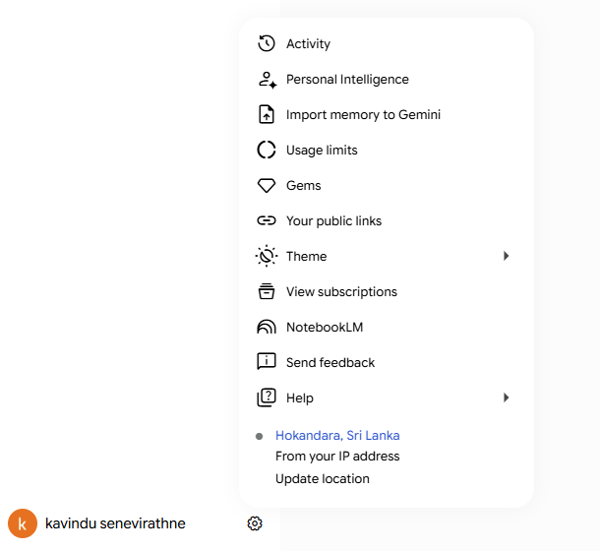

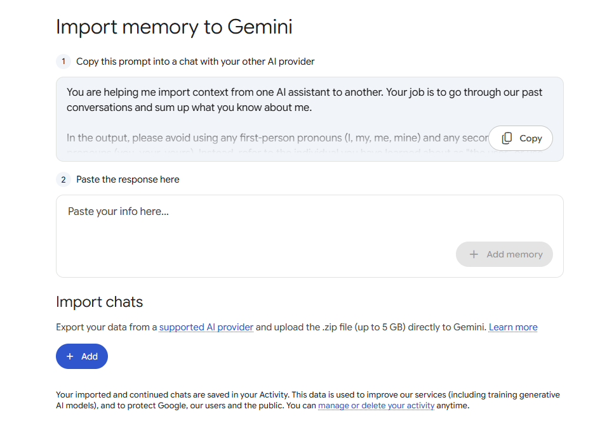
Resources - genai-workshop/Activity-02.md at main · kayifs/genai-workshop

Activity Code – 03 | Prompt Engineering Basics

Sample Email–

Dear Board of Investment Team,

I am writing on behalf of GreenFuture Energy Ltd. We are exploring opportunities to invest in Sri Lanka, particularly in the renewable energy sector.

We would like to understand the available investment opportunities, possible incentives, approval process, and the support provided by BOI for foreign investors.

Could you please share the relevant information and advise us on the next steps?

Thank you.

Kind regards,
Michael Anderson
Business Development Director
GreenFuture Energy Ltd.

Resources - genai-workshop/Activity-03.txt at main · kayifs/genai-workshop
Activity Code – 04 | Prompt Engineering Basics
Sample Text –

A foreign company is interested in establishing a solar panel assembly facility in Sri Lanka. The proposed investment is USD 15 million and the company expects to create 250 direct jobs within three years. They are considering locations near industrial zones with access to ports and skilled workers. The company wants to understand BOI incentives, approval timelines, land availability, and export support. They are also concerned about energy costs, policy stability, and customs procedures.

Resources - genai-workshop/Activity-04.txt at main · kayifs/genai-workshop

Activity Code – 05 | Prompt Engineering Basics

Resource 1: Investor Inquiry Email
Use this for summarization and email drafting exercises.
Dear BOI Team,
We are a manufacturing company based in Singapore and are exploring opportunities to establish a production facility in South Asia. Sri Lanka is one of the countries we are considering due to its strategic location, port access, and skilled workforce.
Our company is particularly interested in setting up a light manufacturing facility for electronic components. The estimated investment would be around USD 8 million in the first phase, with potential expansion in the future. We expect to create approximately 150 direct jobs within the first two years.
We would like to understand the incentives available for foreign investors, the process for obtaining approvals, possible industrial zone locations, expected timelines, and support available for export-oriented businesses.
Could you please advise us on the next steps and whether BOI can arrange an introductory discussion?
Kind regards,
Daniel Lee
Regional Expansion Manager
Exercise prompt: Summarize
Summarize the investor inquiry below in 5 bullet points. Include:
- Who the investor is
- Sector of interest
- Estimated investment value
- Expected benefits to Sri Lanka
- What information they are requesting
Investor inquiry:
[paste email here]

Exercise prompt: Email reply
Act as a BOI Sri Lanka investment promotion officer. Draft a professional and friendly reply to the investor below.
The reply should:
- Thank them for their interest in Sri Lanka
- Acknowledge their proposed investment
- Mention that BOI can guide them on investment opportunities, incentives, approvals, industrial zones, and export support
- Suggest arranging an introductory discussion
- Keep the email concise and professional
Investor inquiry:
[paste email here]

Resources - genai-workshop/Activity-05.md at main · kayifs/genai-workshop

Activity Code – 06 | Draft Emails & Calander Meetings

Tool 1 – Gmail (with Workspace)


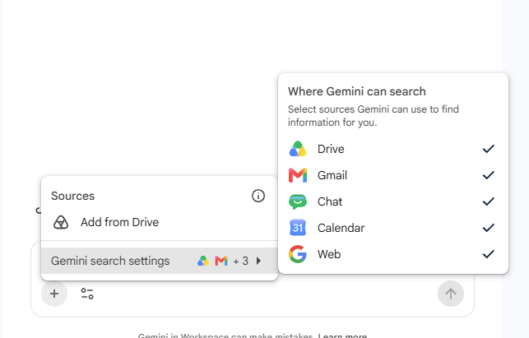

Tool 2 – Gemini Chat
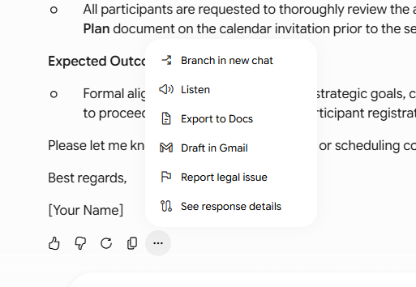
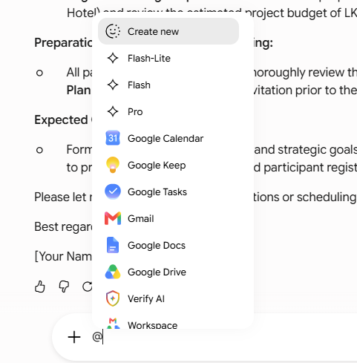

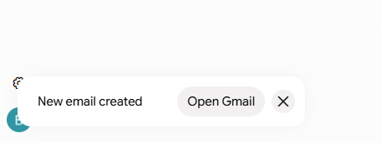

Tool 3 – Gmail Draft Option

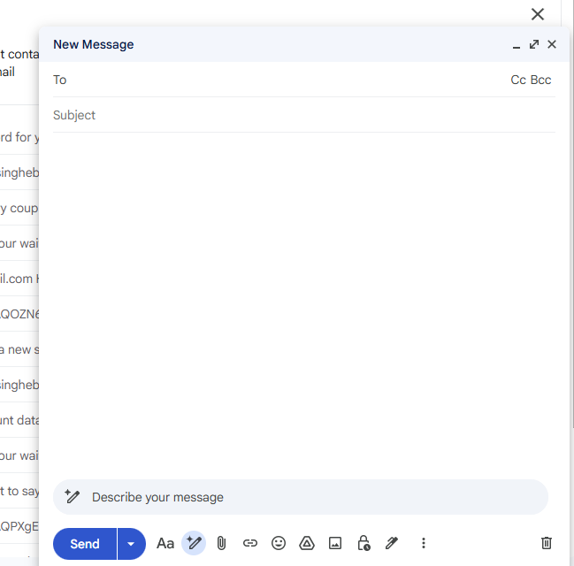
- Try “Help me Schedule” Option.

Tool 4 – Google Calander
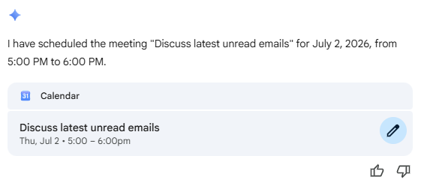

Resources -

Activity Code – 07 | Taking Notes in meetings

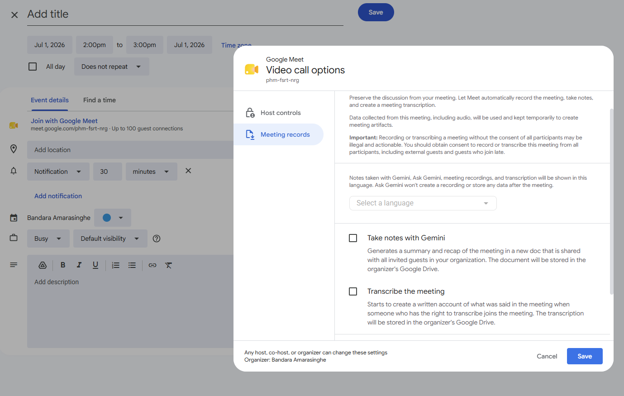


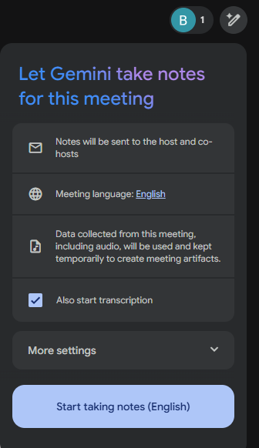

Activity Code 08 | Gemini Gems for Custom Workspaces

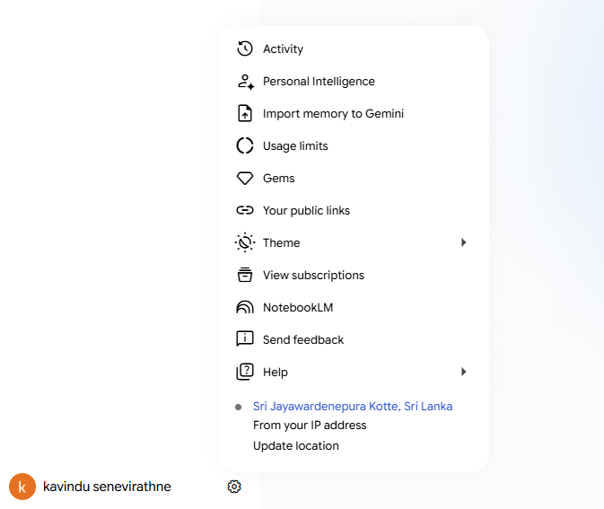

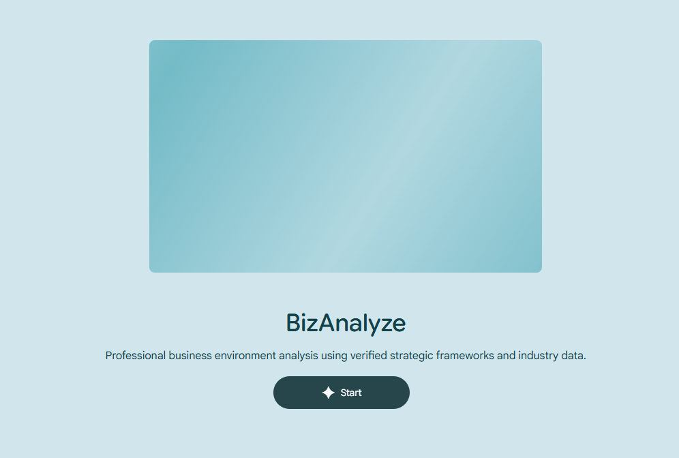

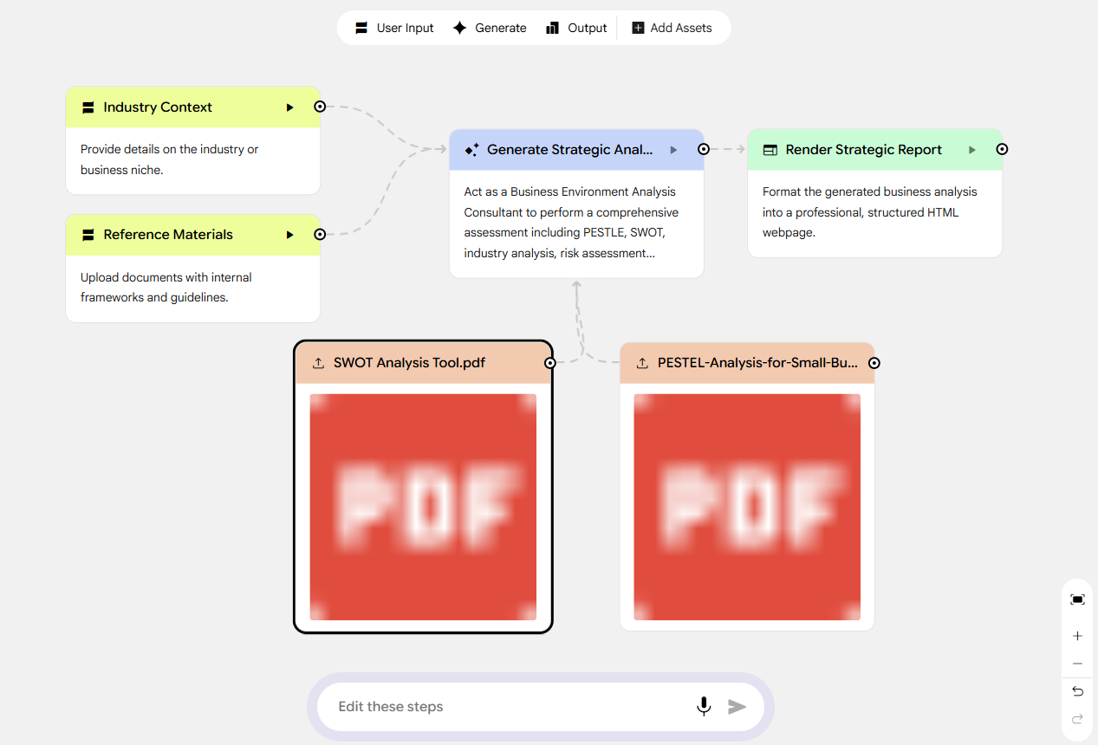
Activity Code – 09 | Create Research Proposal with Deep Research

Tool 1 - Gemini (Deep Research)
- Select Model (Currently Flash Model Support Deep Research)
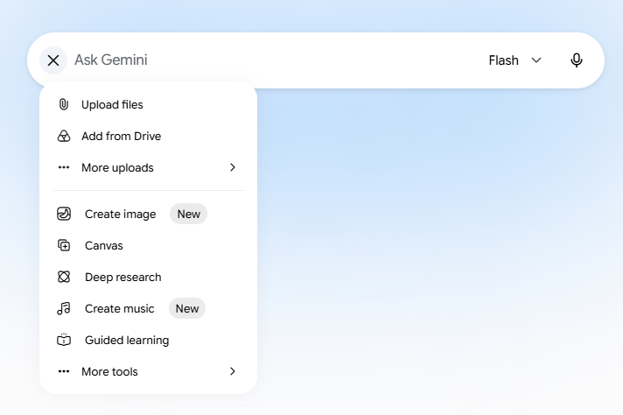
- Add the Prompt
- Export to Docs
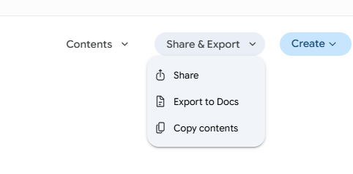
- Do refinements (within Google Docs)
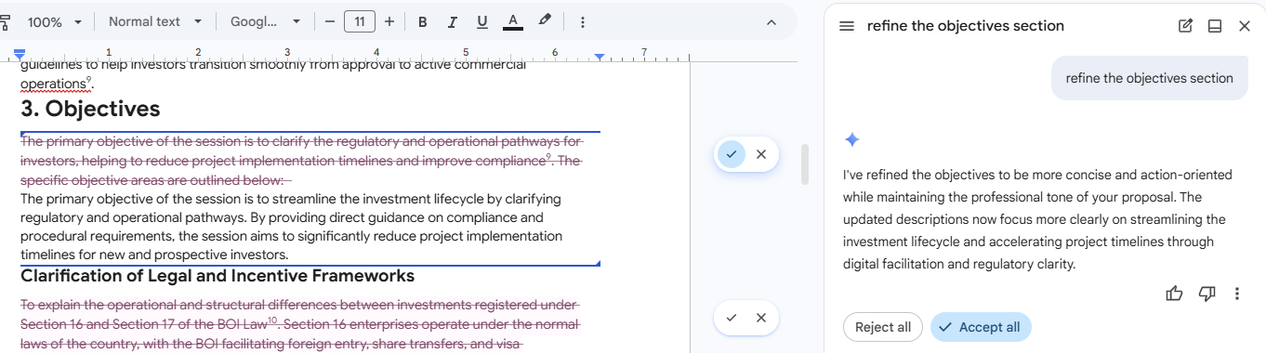

- Create a PowerPoint Presentation (NotebookLM)

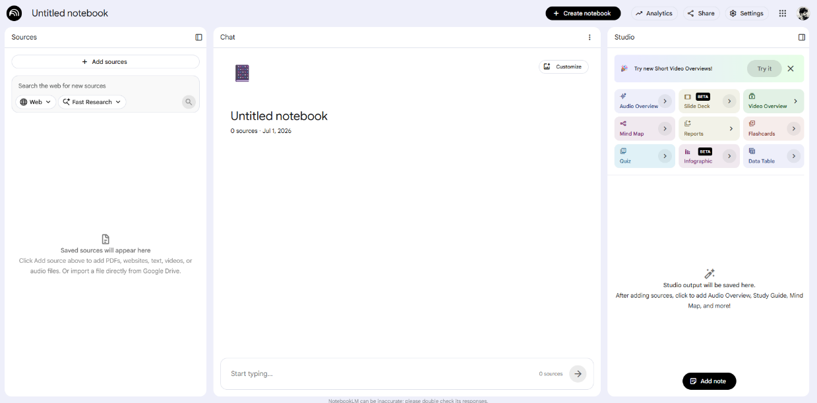

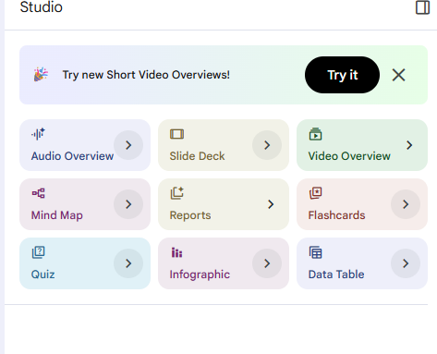

- Create Web Page (NotebookLM)

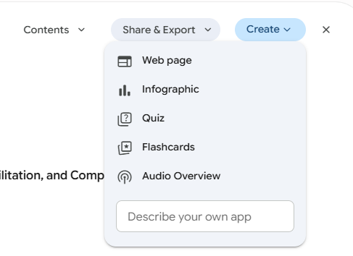
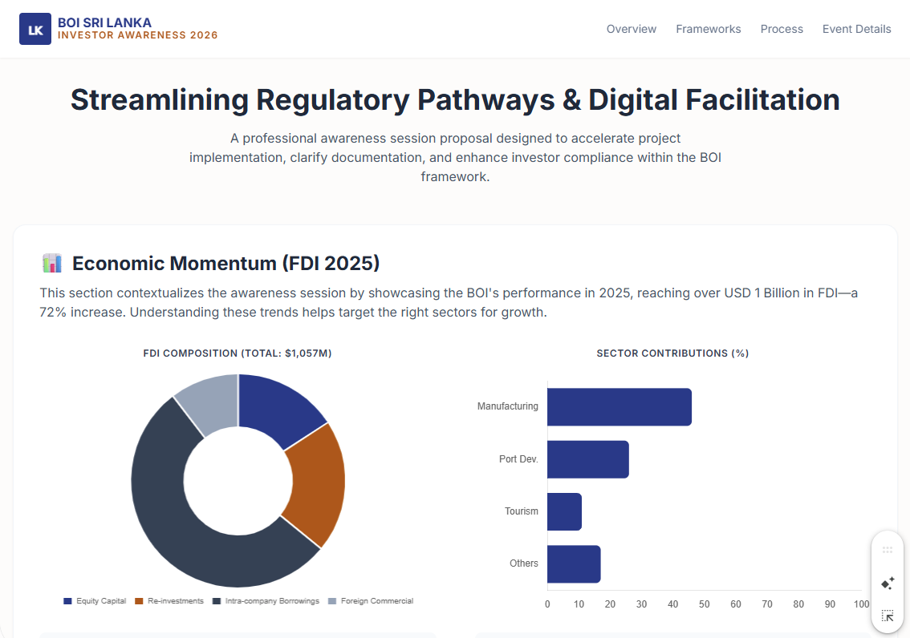

- Create Document Summary (Infographic)
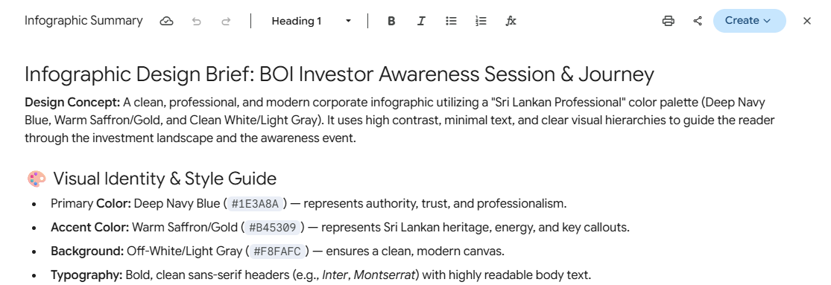

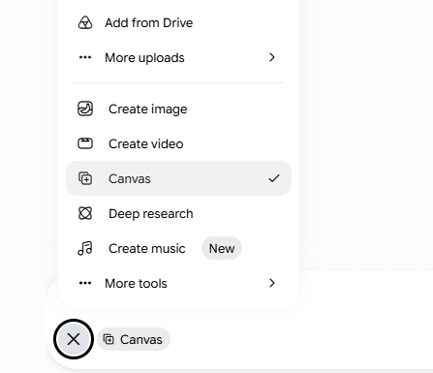
- Generate Infographics

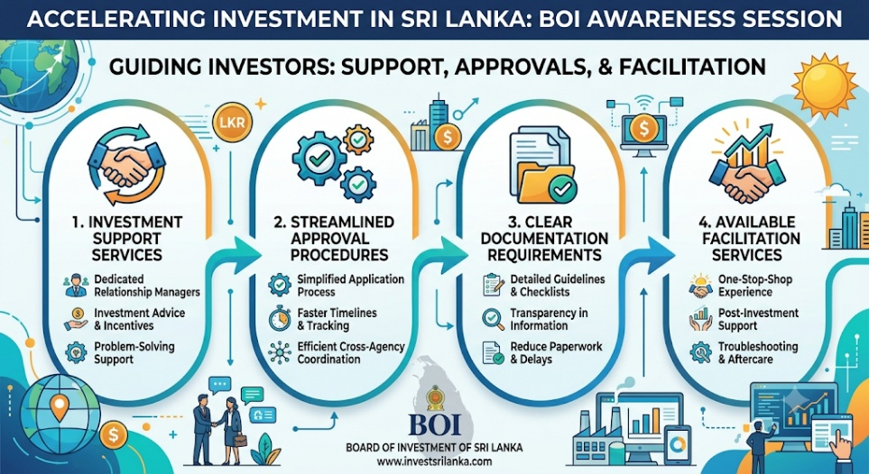

- Generate Video Script
- Generate Video


- Generate an Email Draft

- Create a Meeting using Google Calander
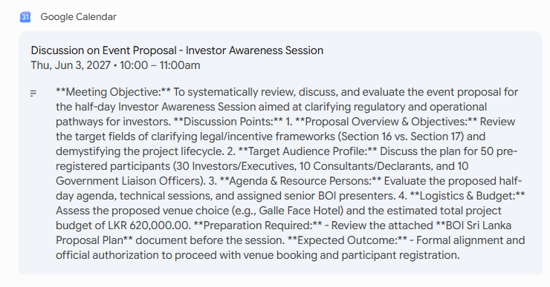

Activity Code – 10 | Data Analysis & Visualization

Tool – Gemini Canvas
- Start a Chat enabling “Canvas” option. (https://gemini.google.com/app)
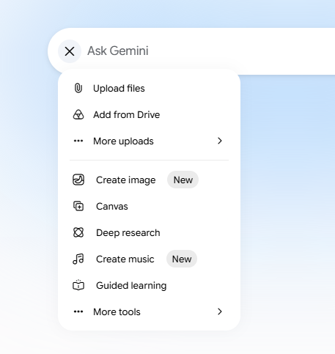

- Prompt and Adjust the prompt, to get the code.
- Create blank a Google Site (https://sites.google.com/)
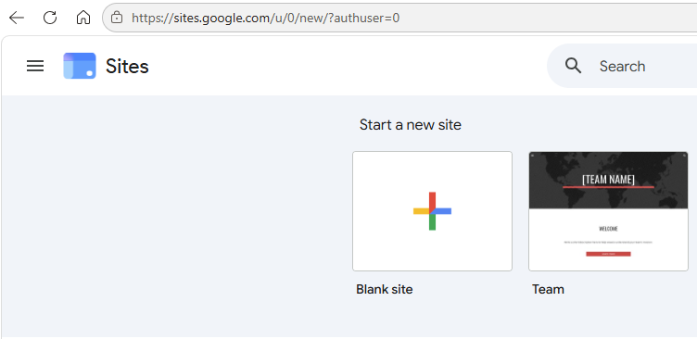

- Go to Pages, Embed the Code.
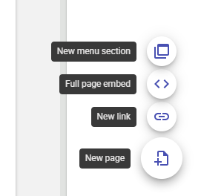

Resources – Dataset Link [companies - Google Drive]

